**POLAND TOWNSHIP**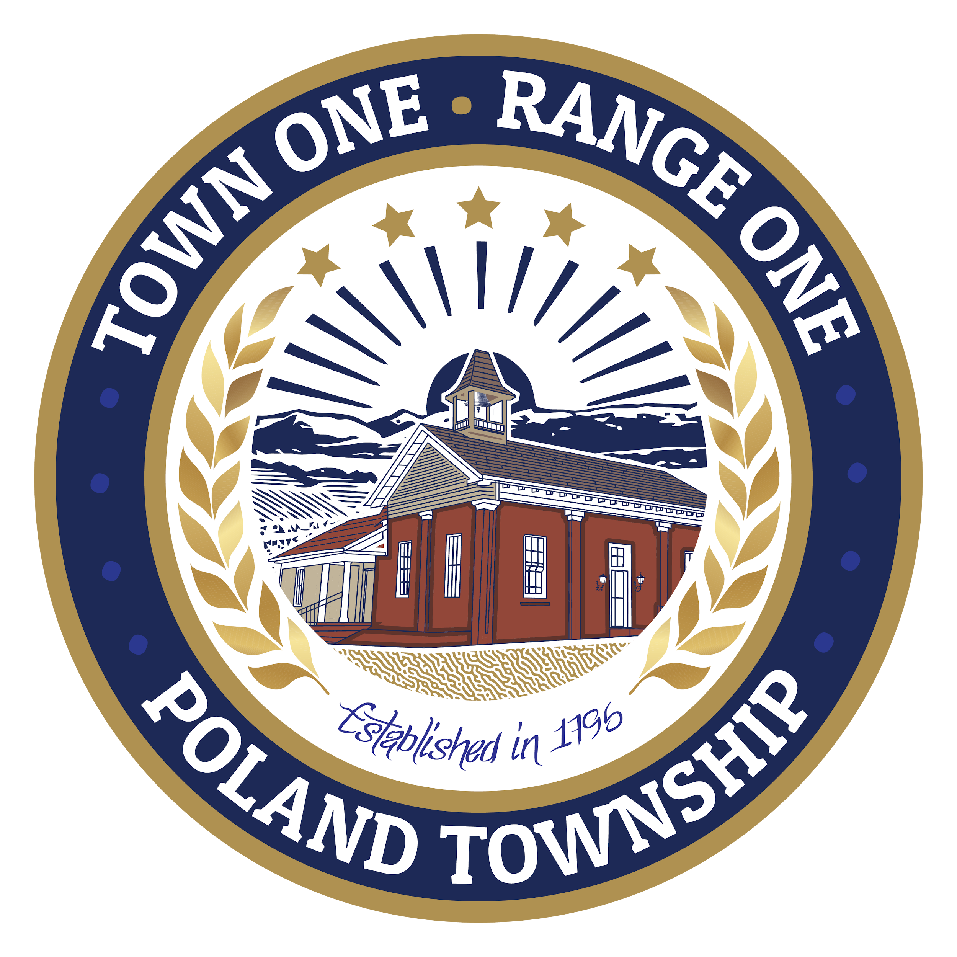

**3339 Dobbins Road, Poland, Ohio 44514**

**Trustees**

**Eric Ungaro - Chairperson**

**Joanne Wollet - Vice Chairperson**

**Edward Kempers - Trustee**

**Fiscal Officer**

**Paul J. Canter**

**Poland Township Trustees**

3339 Dobbins Road

Poland, Ohio 44514

(330) 757-0733

To Whom It May Concern,

The Poland Township Trustees are inviting letters of interest from residents interested in serving on the Poland Township Park Committee. This is a Trustee-appointed advisory committee that meets monthly to discuss park-related issues and make recommendations to the Township Trustees.

If you are a Poland Township resident and are interested in this opportunity, please submit a letter of interest to Mark Covell, Poland Township Administrator. You may send it by mail to the address above or by email to mark.covell@polandtownship.gov. The deadline for submissions is October 1, 2025.

Thank you for your interest in the Poland Township Park.

Respectfully,

Mark Covell